- In this section, you will look at algebraic expressions and see how they can be interpreted using an Expression Mat. To achieve this goal, you first need to understand the different meanings of the “minus” symbol, which is found in expressions such as 5 − 2, −x, and −(−3).
- 2-22. LEARNING LOG
- What does “ – ” mean? Find as many ways as you can to describe this symbol and discuss how these descriptions differ from one another.

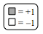
- 2-23. USING AN EXPRESSION MAT
- Your introduction to algebra tiles in Lessons 2.1.1 and 2.1.2 involved only positive values. Today you will look at how you can use algebra tiles to represent “minus.” Below are several tiles with their associated values. Note that the shaded tiles are positive and the un-shaded tiles are negative. The diagram at right will appear throughout the text as a reminder.
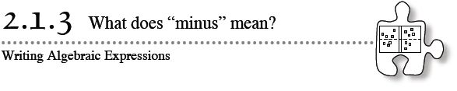
- “Minus” can also be represented with a new tool called an Expression Mat, shown at right. An Expression Mat is an organizing tool that will be used to represent expressions. Notice that there is a positive region at the top and a negative (or “opposite”) region at the bottom.
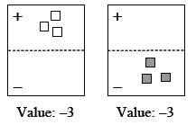
- Using the Expression Mat, the value –3 can be shown in several ways, two of which are shown at right.
- Note that in these examples, the diagram on the left side uses negative tiles in the “+” region, while the diagram on the right side uses positive tiles in the “–” region.
  - Build two different representations for –2x using an Expression Mat
  - Similarly, build 3x − (−4). How many different ways can you build 3x − (−4)?
2-24. As you solved problem 2-23, did you see all of the different ways to represent “minus” that you listed in problem 2-22? Discuss how you could use an Expression Mat to represent the different meanings discussed in class.
2-25. BUILDING EXPRESSIONS
Use the Expression Mat to create each of the following expressions with algebra tiles. Find at least two different representations for each expression. Sketch each representation on your paper. Be prepared to share your different representations with the class.
  - −3x + 4 b. −(y − 2)
  - −y – 3 d. 5x − (3 − 2x)
2-26. In problem 2-25, you represented algebraic expressions with algebra tiles. In this problem, you will need to reverse your thinking to write an expression from a diagram of algebra tiles.
Working with a partner, write algebraic expressions for each representation below. Start by building each problem using your algebra tiles.
a. | b. | c. | d.

