Name:
Date:
Lesson 2.1.3 Homework
- 2-29. Simplify the following expressions by combining like terms. Using or drawing sketches of algebra tiles may be helpful.

  - 2x + 3x + 3 + 4x² + 10 + x

  - 4x + 4y² + y² + 9 + 10 + x + 3x

  - 2x² + 30 + 3x² + 4x² + 14 + x

  - 20 + 5xy + 4y² + 10 + y² + xy

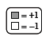
2-30. Find a simplified algebraic expression for each Expression Mat below.
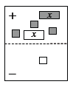
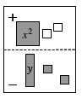
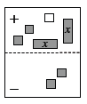

2-31. Write an equation and solve it to find the answer to the question below. Use the 5-D Process to help you write the equation, if needed. Remember to define your variable and to write your answer in a complete sentence.
Susan is buying three different colors of tiles for her kitchen floor. She is buying 25 more red tiles than beige tiles, and three times as many navy-blue tiles as beige tiles. If Susan buys 435 tiles altogether, how many tiles of each color does she buy?

2-32. Without a calculator, compute the value of each expression below.

- −14 + (−31)

- −(−8) − (−2)

- −11 · 24

- 46 ÷ (−23)

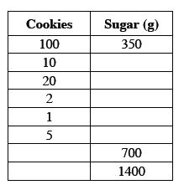
2-33. To bake 100 of his favorite cookies, Mr. Wallis needs 350 grams of sugar.
- How many grams of sugar would he need to bake 10 cookies? What about 20 cookies? Show all work.

- What is the unit rate? That is, how many grams of sugar are needed for 1 cookie?

- To help him know how much sugar to use when baking cookies, Mr. Wallis started to make a table, as shown above. Complete the table

