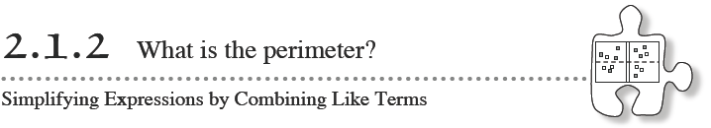
While Lesson 2.1.1 focused on the area of algebra tiles, today’s lesson will focus on the perimeter. What is perimeter? How can you find it? By the end of this lesson, you will be able to find the perimeter of complex shapes formed by collections of tiles.
- Your class will also focus on several ways to find perimeter, recognizing that there are different ways to “see” or recognize perimeter. Sometimes, with complex shapes, a convenient shortcut can help you find the perimeter more quickly. Be sure to share any insight into finding perimeter with your teammates and with the whole class.
- 2-11. Your teacher will provide a set of algebra tiles for your team to use today. Separate one of each shape and review its name (area). Then find the perimeter of each tile. Decide with your team how to write a simplified expression that represents the perimeter of each tile. Be prepared to share the perimeters you find with the class. (Show under the “flap”)
- 2-12. Each part of an expression that is separated by addition or subtraction signs is called a term. If two terms contain the same variable(s), including the same exponents, if any, they are called like terms.
- Match the terms in the left column with the like terms that match them in the right column.
- 3x | - 6y²
- –4y² | - 7xy
- 6a⁴ | - 13
- 10s | - –7c
- –8 | - 9a⁴
- 6xy | - s
- c | - 5x

- 2-13. For each of the shapes formed by algebra tiles below:
  - Use tiles to build the shape.
  - Sketch and label the shape on your paper. Then write an expression that represents the perimeter.
  - Simplify your perimeter expression as much as possible. This process of writing the expression more simply by collecting together the parts of the expression that are the same is called combining like terms.

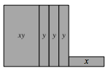
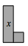
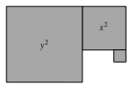
- 2-14. Calculate the perimeter of the shapes in problem 2-13 if the length of each x-tile is 3 units and the length of each y-tile is 8 units. Show all work.

