Name:
Date:
Lesson 2.1.2 Homework
- 2-17. Simplify each algebraic expression below, if possible. If it is not possible to simplify the expression, explain why not.

  - 3y + 2y + y² + 5 + y

  - 3y² + 2xy + 1 + 3x + y + 2x²

  - 3xy + 5x + 2 + 3y + x + 4

  - 4m + 2mn + m² + m + 3m²

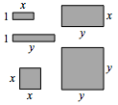
2-18. If the tiles have the dimensions shown at right, what is the name of the tile collection below? (That is, what is the total area of all of the pieces?) Write the expression algebraically, using x, x², y, y², and xy.
2-19. Remember that one meaning of the word “evaluate” is to replace a variable with a number and to calculate the result. For example, evaluating the expression x² when x = −2 results in the solution (−2)² = 4.
- Evaluate the expressions below for the given values.

- −4d + 3 if d = −1

- k − m if k = 4 and m = −10
- $\frac{t}{w}$ if t = 6 and w = −3

- x² + y² if x = 7 and y = 5

2-20. Solve the following problems.
  - A typical small bag of colored candies has about 135 candies in it, 27 of which are blue. At this rate, how many blue candies would you expect in a pile of 1000 colored candies?

  - Ten calculators cost $149.50. How much would 100 cost? 1000? 500?

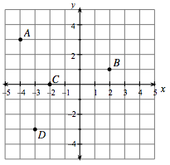
- 2-21. Examine the graph below.
- Name the coordinates of points A, B, C, and D in (x, y) form.

- Draw your own set of axes like the ones shown on the right. Then plot points E(5, 2), F(–3, –1), G(0, –4), and H(2, –3).

