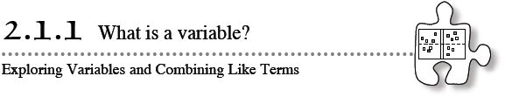
- In Algebra and in future mathematics courses, you will work with unknown quantities that can be represented using variables. Today manipulatives called “algebra tiles” will be introduced to help you and your teammates answer some important questions, such as “What is a variable?” and “How can we use it?”
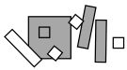
- 2-1. Your teacher will distribute a set of algebra tiles for your team to use during this course. As you explore the tiles, address the following questions with your team. Be prepared to share your responses with the class.
  - How many different shapes are there? What are all of the different shapes?

  - How are the shapes different? How are they the same?

  - How are the shapes related? Which fit together and which do not?

2-2. Draw a picture of each type of tile on your paper and answer questions a.-d.
  - The algebra tiles will be referred to by their areas. Since the smallest square has a length of 1 unit, its area is 1 square unit. Thus, the name for this tile is “one” or a “unit tile.” Label your drawing of this tile with its side lengths and area.

  - Can you use the unit tile to find the other lengths? Why or why not?
  - If you cannot use the unit tile to measure all of the other side lengths of the other tiles, how can you label them so that you can find their area? Discuss this with your team and be prepared to share your ideas with the class.
  - Label your drawings and then name the other tiles using their areas. Be sure to use what you know about the area of a rectangle and the area of a square.
2-3. JUMBLED PILES
Your teacher will show you a jumbled pile of algebra tiles and will challenge you to write a name for the collection. What is the best description for the collection of tiles? Is your description the best possible?

2-4. Build each collection of tiles represented below. Then name the collection using a simpler algebraic expression, if possible. If it is not possible to simplify the expression, explain why not.
  - 3x + 5 + x² + y + 3x² + 2

  - 2x² + 1 + xy + x² + 2xy + 5

  - 2 + x² + 3x + y² + 4y + xy

  - 3y + 2 + 2xy + 4x + y² + 4y + 1

