Name:
Date:
Lesson 2.1.1 Homework
- 2-6. Suppose you put one of your x-tiles and two unit tiles with another pile of three x-tiles and five unit tiles. What is in this new pile? Write it as a sum.

- 2-7. Suppose one person in your team has two x²-tiles, three x-tiles, and one unit tile on his desk and another person has one x²-tile, five x-tiles, and eight unit tiles on her desk. You decide to put all of the tiles together on one desk. What is the name for this new group of tiles?

- 2-8. Find the area and perimeter of each shape. Assume that all corners are right angles. Show all work.
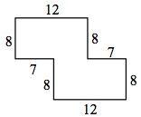
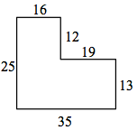

2-9. One meaning of the word evaluate is to find the value of an expression. To evaluate, replace a variable with a number and calculate the result. For example, when you are asked to evaluate the expression 4x − 2 when x= −7, you would put −7 in place of the variable and calculate: 4 · (−7) − 2 = −30.
- Evaluate the expressions below for the given values of x and y.

- $\frac{6}{x}$ + 9 if x = 3

- 8x − 3 + y if x = 2 and y = 1

- 2xy if x = 5 and y = −3

- 2x² − y if x = 3 and y = 8

2-10. For the following problem, define a variable and write an equation (use the 5-D Process if needed). Then solve the equation to solve the problem. Write your solution as a sentence.
A cable 84 meters long is cut into two pieces so that one piece is 18 meters longer than the other. Find the length of each piece of cable.

