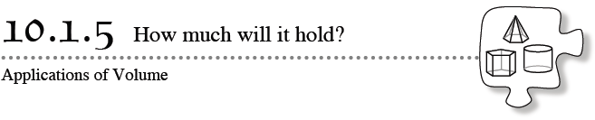
In this section, you have learned how to find the surface area and the volume of several kinds of solids – cylinders, cones, pyramids, and spheres. These skills can be very useful when solving real-world problems such as the one that you will encounter in this lesson. Use all of what you have learned and work together with your team to accomplish a challenging task!
- 10-62. Sam Mallory, the owner of Mallory’s Ice Cream Shop, wants to be able to advertise that his cones hold the most ice cream. His cones are made out of circular waffles with a set diameter. His employees cut a wedge-shaped piece from the circle and then fold it into a cone shape. He needs help determining how they can do this to create a cone with the largest volume. You have been hired to help solve this problem.
- As you work through the steps below, neatly record your work. When you are finished, you will make a presentation of your findings for the owner.
- Your Task: Using the materials provided by your teacher, create cones of various sizes and calculate their volumes. Determine the angle of the removed sector (a wedge-shaped piece of the circle) that results in the largest volume. Follow the steps below for creating a cone
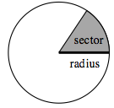
- Before you get started, decide on the angle of the sector that each pair in your team will use to create a cone. Repeat the process below using different angles until you think that you have solved the task and found the largest volume possible.
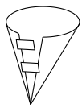
  - Locate the center of the circle by folding it in half in two different directions. The intersection of the folds is the center of the circle. Place a dot at the center.
  - Use a ruler to draw a radius of the circle.
  - Use a protractor to measure the angle of the sector that you chose to be removed. Then use the ruler to draw the second radius for that angle.
  - Cut out the sector and then tape the edges of the sector together to create a cone.
  - Use a ruler to make the measurements of the cone that you need and calculate its volume. Record your work.
- 10-63. Your team needs to present your findings to the owner of the ice-cream shop. Create a stand-alone poster displaying your results and advice for the owner. Be sure to include enough information that someone unfamiliar with the problem will understand your work and how you came to your conclusion. Also be sure to make your poster neat and presentable.
- 10-64. Additional Challenge: Now that the ice-cream-shop owner knows how to create cones with the largest volume, he wants to know how many cones he can make with each tub of ice cream.
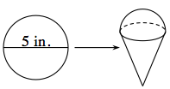
- He has measured a cylindrical tub and informed you that it has a diameter of 9.5 inches and a height of 10.5 inches. Each waffle cone is created from a circular waffle with a diameter of 5 inches. Then it is packed full and has a half spherical scoop on the top, as shown in the diagram at right.
- How many cones can the owner create with each tub of ice cream?

