Name:
Date:
Lesson 10.1.5 Homework
- 10-65. Find the volume of a sphere with a radius of 620,000 miles. Write your answer using scientific notation.

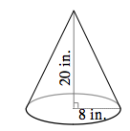
- 10-66. Find the volume of the cone.

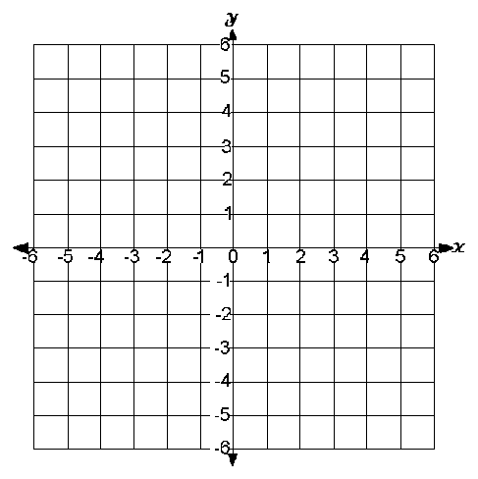
- 10-67. Graph the points (0, 2), (6, 2), (7, 4), (1, 4) and connect the points in order to create a parallelogram. What is the perimeter of the parallelogram? Is the perimeter a rational or irrational number? How do you know?

- 10-68. Simplify each of the following expressions.

  - (5x³)²
  - 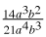
  - 2m³n² · 3mn⁴

- 10-69. First decide if the triangles below are similar. Then, if they are similar, use the information in each diagram to solve for x.

  - 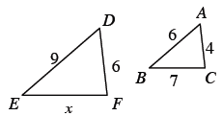
  - 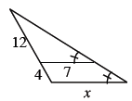
Careful!

- 10-70. The label of the Aloha Pineapple Juice can is 7 inches high and has an area of 140 square inches. What is the diameter of the can?

- 10-71. Sketch an example of a graph that meets the description below.

  - non-linear and decreasing
  - linear and increasing

