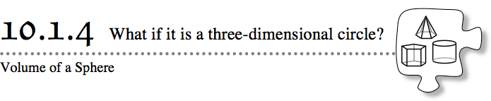
So far in this chapter you have been finding the volume of three-dimensional solids with circular bases, but what if the object is a three-dimensional circle? A sphere is a three-dimensional object shaped like a ball. Every point on the outside of a sphere is the same distance from its center. Today you will use what you have learned about the volume of a cylinder to find the volume of a sphere.
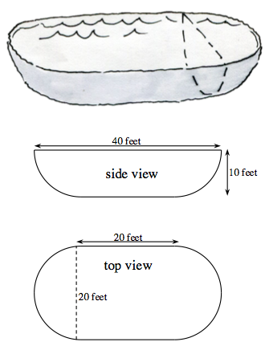
- 10-47. Myron’s family is putting a pool in their backyard. He is so excited that he wants to figure out how long it will take to fill the pool! He found the blueprints for the pool and recreated the sketches at right, but he is not quite sure how to use them to find the volume of the pool.
- What three-dimensional figures does Myron need to be able to find the volume of before he can determine the volume of the pool?

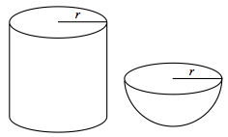
- 10-48. Your teacher will lead you through a demonstration about the volume of a sphere.
  - How are the diameter of the half sphere related to the diameter and height of the cylinder?
  - How many half spheres full of rice were needed to fill the cylinder to the height of the sphere’s diameter?
  - Based on the demonstration, describe how the volume of a full sphere compares to the volume of a cylinder when their heights and diameters are equal.

- 10-49. VOLUME OF A SPHERE
- What is the formula for the volume of a sphere? How can you use what your class figured out about the relationship between the cylinder and the bowl in problem 10-48 to generalize a formula for the volume of a sphere?
  - If 3 bowls of water completely filled a cylinder in which the diameter was the same as the height, how many spheres is this? Write your answer as a fraction.
  - Write an equation relating the volume of a sphere and the volume of a cylinder.
  - If the height and diameter of the cylinder are equal, write an equation for the height of the cylinder using the radius.
  - Use substitution and your equation from part (b) to write an equation for the volume of a sphere. Simplify your answer.
- 10-50. Use what you have learned in the previous problems to help Myron calculate the volume of the pool in problem 10-47.

- 10-51. If there is 0.1337 of a cubic foot in 1 gallon, how many gallons of water will it take to fill Myron’s swimming pool completely?

- 10-52. Since Myron wants to know how long it will take to fill the pool, he needs to know how fast water flows out of the hose. He gets an empty gallon jug, turns the water up as high as possible, and finds that it takes 6 seconds to fill the jug. At this rate, how long will it take to fill the entire pool?

- 10-53. If a sphere has a volume of 36π ft³, what is the radius? Work with your team to write and solve an equation to find the radius of the sphere.

