Name:
Date:
Lesson 10.1.4 Homework
- 10-55. Calculate the volume of each sphere described below.

  - radius = 5 cm
  - diameter = 3 feet

10-56. If the volume of a sphere is 113.04 ft³, write and solve and equation to find the radius.

- 10-57. Find the volume of each shape below.

  - Rectangle-based prism
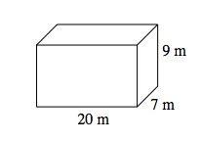
  - Rectangle-based pyramid
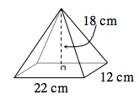

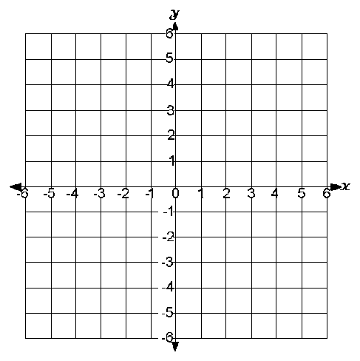
- 10-58.
  - Make a table for the rule y = 2x³ that includes x-values from –3 to 3.

  - Graph the rule on graph paper.
  - What kind of growth does the rule have? Is the rule a function? Explain your answers.

- 10-59. Sarah and three of her friends left her house for a long bike ride on the river bike path. They rode for three hours at 10 miles per hour and then rested for an hour while they ate their lunches. After lunch, they raced each other back to Sarah’s house at 15 miles per hour.
  - Draw a graph that could represent this situation. Place “Time (hours)” on the horizontal axis and “Distance (miles from Sarah’s house)” on the vertical axis.
  - Describe each part of the graph using the following words: linear, nonlinear, decreasing, increasing, and constant.

- 10-60. Sherice can fill lemonade cups at a rate of four cups per minute.
  - How many cups can she fill in 6 minutes?

  - How many cups can she fill in 10 minutes?

  - If Sherice fills c cups in t minutes, write an equation that relates c and t.

- 10-61. Calculate the value of x.

  - 
   