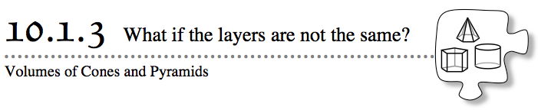
Cones and pyramids are three-dimensional objects that have only one base, and that come to a point opposite their base. A cone has a circular base. A pyramid has a base that is a polygon and lateral faces that are triangles. Today you will be investigating how to use what you know about cylinders and prisms to find the volume of a cone and a pyramid.
10-32. HOW MUCH SHOULD IT COST?
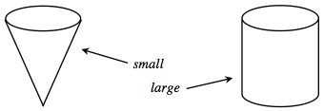
- You have a choice of purchasing a small or a large serving of popcorn at the movies. A small popcorn comes in a cone and costs $1.50, and a large popcorn comes in a cylinder that costs $3.50. Both containers have the same height and have bases with the same circular area. Based on their prices, discuss with your team which container of popcorn you think is a better deal. Be prepared to share your reasons with the class.
- 10-33. Your teacher will lead you through a demonstration about the volume of a cone.
  - How are the radius and height of each cone related to the radius and height of each corresponding cylinder?
  - Sketch each cone and cylinder on your paper, and estimate which cone will have a greater volume.
  - How many cones full of rice were needed to fill each corresponding cylinder?
  - Based on the demonstration, describe how the volume of a cone compares to the volume of a cylinder when their heights and base areas are equal.

- 10-34. Based on the relationship you found in problem 10-33, determine what a fair price would be for the cylinder of popcorn in problem 10-32 if the cone of popcorn costs $1.50. At the advertised prices, which popcorn is the better deal?
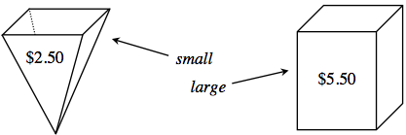
- 10-35. A different movie theater sells popcorn in the containers shown below. This time, the small container is a pyramid priced at $2.50. The large container is a prism with the same height and base as the pyramid, and it is priced at $5.50. At this theater, which popcorn do you think is a better deal? Be prepared to give reasons for your prediction.
- 10-36. Your teacher will now lead you through another demonstration to help you decide if you need to adjust your thinking about the relationship between the volume of a pyramid and a prism that have the same base and the same height. After you have seen the demonstration with the pyramid and the prism, determine which container of popcorn is a better deal. Justify your answer.
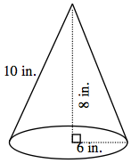
- 10-37. Ann and Dan were trying to find the volume of the cone to the right. Ann thinks that the cone is 8 inches tall, and Dan thinks that the cone is 10 inches tall. Write them a note explaining who is correct.

- 10-38. Ann, Dan, and Jan calculated the volumes of some shapes and got different answers. Look at their work shown below and make a sketch of the shape that each set of calculations might represent. Why do Dan’s and Jan’s calculations have the same result even though they look different?
- Dan's work: $V=\frac{\left(4^{2}π\right)\left(9\right)}{3}=150.8$cm³
- Ann's work: $V=\left(4^{2}π\right)\left(9\right)=452.4$ cm³
- Jan's work: $V=\frac{1}{3}\left(4^{2}π\right)\left(9\right)=150.8$ cm³
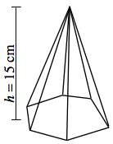
- 10-39. Find the volume of the pyramid below. The hexagonal base has an area of 128 cm².

