Name:
Date:
Lesson 10.1.3 Homework
- 10-41. Find the volume of the cone shown in problem 10-37.

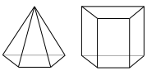
- 10-42. The pyramid at right has a volume of 312 cubic feet. If the prism next to it has the same base area and height, what is its volume? Explain how you know.

- 10-43. Which table or tables below show a proportional relationship? Justify your answers.
  - 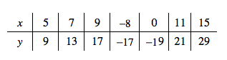
  - 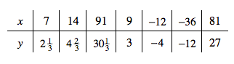
  - 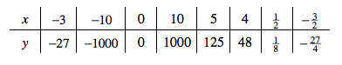

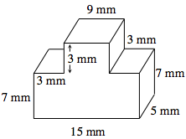
10-44. Find the volume of the prism at right. All angles are right angles.

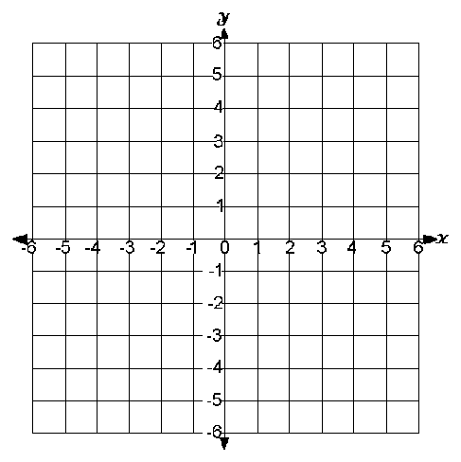
- 10-45. Graph the points (−2, 4), (2, 1), (−2, −2) and connect the points to create a triangle.
  - What is the perimeter of the triangle?

  - Translate the triangle up 2 and right 3. What are the new coordinates?

  - What is the perimeter of the triangle after its translation in part (b)?

- 10-46.
  - Make a table for the rule that includes x-values from −1 to 10. What happened?

  - Graph the rule on graph paper.
  - What kind of growth does the rule show? How do you know?

  - Is this relationship a function? How do you know?

