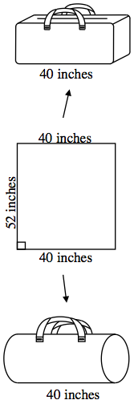
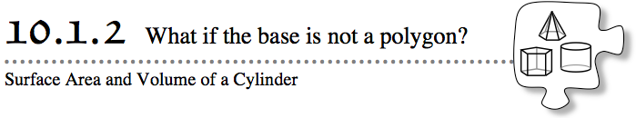
Soup cans and rolls of paper towels are examples of cylinders. Cylinders are like prisms in many ways. However, a prism has a polygon as its base, while a cylinder has a circle as its base. In this lesson, you will compare the surface areas and volumes of prisms and cylinders.
- 10-18. COMPARING THE GYM BAGS
- The CPM Sports Company is planning a new product line of gym bags. The outside of the bag (without the ends) will be made with a rectangular piece of cloth that is 40 inches by 52 inches. The company is trying to decide whether the end pieces will be squares or circles. CPM designers want to compare the surface area and volume of each bag and consider the advantages and disadvantages of each shape. Your team will help provide data for the designers’ decision.
- Use a standard piece of paper that measures 8.5 inches on one edge and 11 inches on the other to create a model of each gym bag. To model the square-based prism:
  - Fold the paper in half so that the 8.5-inch edges match up, then unfold.
  - Fold each 8.5-inch edge in to the center crease, then unfold.
  - Tape the 8.5-inch edges together to form the lateral faces (the faces that are not the bases) of a square-based prism. The open squares at either end are the bases.
- Use a new piece of paper to model the cylinder:
  - Roll the paper so that one 8.5-inch edge matches up with the other.
  - Tape the edges together to form the lateral face of a cylinder. The open circles formed at each end are the bases.
- Your task: Using the models for reference, find the surface area and volume of each gym bag. How much fabric will it take to make each bag? How much will each bag hold? Remember that the shorter length on the paper (8.5 inches) models the 40-inchdimension of the cloth, and the longer length (11 inches) models the 52-inch dimension of the cloth. The model you have created is not to scale.
- 10-19. Focus first on the square-based prism. Sketch the prism on your paper, and then use the dimensions given for the cloth to answer the questions below.
  - What is the perimeter of the square base? How long is each side of the square base?
  - What is the surface area of the prism?
  - Calculate the volume of the prism.
- 10-20. Sketch the cylinder on your paper.
  - On your sketch, label all of the lengths that you know. What shape is the lateral face of the cylinder? This is the face formed by the original piece of paper. Find the area of the lateral face and the area of each base. If you do not have enough information to find the area, list the measurements that you need.
  - Melissa is looking at the base of the cylinder and realizes that the only measurement she knows is the circumference of the circle. She thinks she can use the circumference to find out other measurements. What is the circumference of this circle? What other lengths can Melissa find using this measurement?
  - Find the area of each base of the cylinder and then calculate the total surface area.
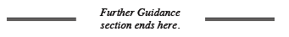
- 10-21. To find the volume of the cylinder, Melissa started by comparing it to a prism. “To find the volume of a prism, I slice it into equal layers. I wonder if the same method will work for a cylinder?” she asks. Work with your team to answer Melissa’s question. How could a cylinder be sliced into layers? What shape would each layer be? Find the volume of the cylinder.

- 10-22. How does the amount of fabric required to make the cylindrical bag compare to the amount of fabric required to make the square-based-prism bag? How much will each bag hold? Based on this information, which bag style do you think the CPM sports company should make? Explain your reasoning.
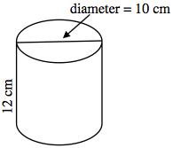
- 10-23. Find the surface area and volume of the cylinder below. Show your work clearly.

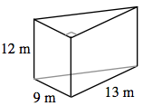
- 10-24. Additional Challenge: Louise calculated the volume of the prism at right to be 702 m³. She is trying to find the surface area, but she needs help.
  - Sketch the shape on your paper and label any lengths that you know. How can you find the lengths of the unlabeled edges?
  - What are the length and width of each rectangle?
  - What is the total surface area of the shape?

