Name:
Date:
Lesson 10.1.2 Homework
- 10-26. Find the area of the base of each cylinder below, and then calculate the volume of each cylinder. Show your steps.
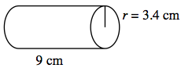
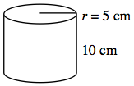

- 10-27. What is the volume of a hexagonal-based prism with a height of 12 in. and a base area of 62 in.²? Would the volume be different if the base were a pentagon with an area of 62 in.²? Explain.

- 10-28. Find the length of the side labeled x in each of the right triangles pictured below. Identify each answer as a rational or irrational number.

  - 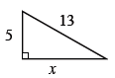

  - 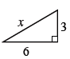
  - 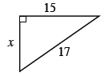

10-29. Simplify each expression.

  - 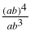
  - 8x^{–3}(8x)²

10-30. Simplify each expression.

10-31. Tim wants to invest some money that his grandmother gave him. He has $2000 and can put it in an account with simple interest or an account with compound interest.
  - The simple interest account has an interest rate of 10%. With this interest rate, what is the total amount in the bank after 5 years?

  - The compound interest account is also for 5 years (compounded yearly), but it has an interest rate of 8%. Find the total amount that he would have in this account.

  - Which account is a better investment?

