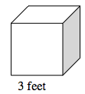
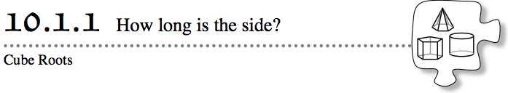
You have previously calculated the volumes and surface areas of cubes (and, more generally, prisms) using the lengths of the sides. But what if you wanted to reverse this process? In this lesson, you will learn how to determine the length of the side of a cube when you already know the volume. You will learn about a new operation, which is similar to the square-root operation, that will help you do this.
- 10-1. Using the cube at right as a model, work with your team to create two problem situations that would require knowing the surface area of the cube. Then make another two problem situations that would require knowing the volume of the cube.
- 10-2. Find the surface area and the volume of the cube in problem 10-1. Show your steps.
- 10-3. A different cube has a side of length 5. Write two expressions that would represent how to find the volume of the cube. One expression should use exponents.
- 10-4. Now reverse the process. If you know the volume, how long is the side? Given the volumes of different cubes below, work with your team to find the length of a side of each cube.
  - 8 un³ b. 125 m³

  - 1000 ft³ d. 40 in.³
- 10-5. In problem 10-4, did you find the solution by guessing and checking, or did you find a special key on your calculator that helped?
- 10-6. If s = the length of a side of a cube, then s³ or “s cubed” represents the volume of the cube. If the volume of the cube is 64 cubic units, write an equation (using s) stating that volume is 64 cubic units.

- 10-7. In Chapter 9, you solved equations with squares, such as x² = 16, by using the square-root operation, . To solve equations with cubes, such as x³ = 64, you need an operation that undoes cubing. You need the operation called cube root. It uses the symbol $\sqrt[3]{}$. Find the cube-root key on your calculator. Different calculators perform this operation in different ways, so figure out how to do this on your calculator and then find $\sqrt[3]{64}$ to get the solution to x³ = 64.
- 10-8. If you have not already done so, use the $\sqrt[3]{}$ key on your calculator to check your answers for problem 10-4.
- 10-9. Just like with perfect squares and square roots, cube roots of perfect cubes are positive integers. Some of them are listed below.
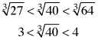
- Cube roots of non-perfect cubes like $\sqrt[3]{40}=3.419951…$ are irrational numbers. Without a calculator, you can approximate the cube root to be between consecutive integers, as you did with square roots. Look at the example to the right.
- Approximate each of the following cube roots between consecutive integers. Write each answer in the same way as the above example.
- a. $\sqrt[3]{10}$ b. $\sqrt[3]{100}$ c. $\sqrt[3]{52}$ d. $-\sqrt[3]{150}$

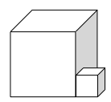
- 10-10. The office building where Ryan works is made up of two cube-shaped pieces. At lunchtime, Ryan and his other office workers walk around the edge of the building for exercise. If the volume of the larger part is 65,000 m³ and the volume of the smaller part is 4000 m³, what is the distance around the edge of the building?

