Name:
Date:
Lesson 10.1.1 Homework
- 10-12. Find the cube root of the following numbers. Use your calculator as needed and round any decimal answers to the nearest hundredth. Identify each answer as a rational or irrational number.

  - 1728
  - 54
  - 0.125

- 10-13. Given that the volume of a certain cube is 125 cubic inches, find the dimensions given below.

  - Find the length of one side of the cube.
  - Find the surface area of the cube.

- 10-14. Find the area and perimeter of the shape below. Show your steps.
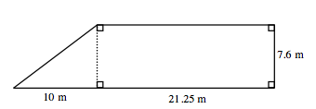

- 10-15. Change each number below from a decimal to an equivalent fraction. For help with repeating decimals, review the Math Notes box from Lesson 9.2.4.

  - 0.72
  - 0.175

- 10-16. Johanna is planting tomatoes in the school garden this year. Tomato plants come in packs of 6. She needs 80 plants in the garden and already has 28. How many packs of plants will she need?

- 10-17. Solve the following equations for the given variable.

  - 3x + (−4) = 2y + 9 for y

  - 12 = $\frac{6}{7}$x for x

  - for x

  - for y

