Name:____________________

Date:_______________

Chapter 5 Review

* **CL 5-62.** Solve each equation.
  1. 3(2*x* − 1) + 7 = −44 b. 6(2*x* − 5) = −(*x* + 4)
* **CL 5-63.** Solve for the indicated variable.

a. 2*x* + 5*y* = 10 (solve for *y*) b. 3(*x* + 2) = *y* − 6 (solve for *x*)

* **CL 5-64.** Examine the tile pattern below. Then complete parts (a) through (c) that follow.
  1. 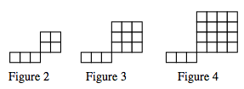Draw Figure 1 and Figure 5.



* 1. Make an *x*→ *y* table for the pattern.

|  |  |  |  |  |  |  |  |  |
| --- | --- | --- | --- | --- | --- | --- | --- | --- |
| Figure number (x) |  |  |  |  |  |  |  |  |
| Number of Tiles (y) |  |  |  |  |  |  |  |  |

* 1. Make a complete graph. Include points for Figures 0 through 5



**CL 5-65.** Use the table at right to complete parts (a) and (b) below.

* 1. Complete the table.

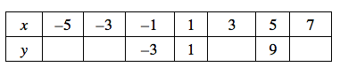

* 1. Find the rule (*y* = ?).
* **CL 5-66.** For each pair of lines below, solve the system first by graphing and then algebraically using the Equal Values Method. Explain how the graph confirms the algebraic result.

a. y = 7x − 5 and y = −2x + 13 b. y = 3x − 1 and y = 3x + 2

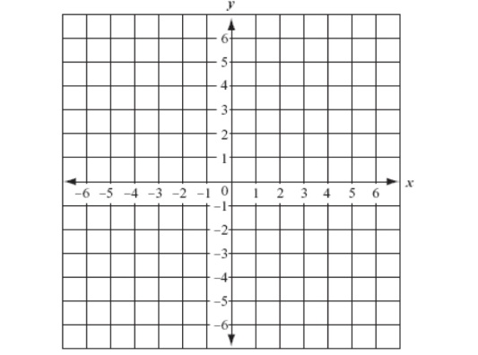

**CL 5-67.** To rent a jet ski at Sam’s costs $25 plus $3 per hour. At Claire’s, it costs $5 plus $8 per hour. At how many hours will the rental cost at both shops be equal?

a, Write an equation that represents each shop’s charges. What do your variables represent?

1. Solve the problem. Show your work.

**CL 5-68.** Solve each equation.

* 1. http://textbooks.cpm.org/images/cc3/chap05/CC3_CL5-68a.gif
  2. http://textbooks.cpm.org/images/cc3/chap05/CC3_CL5-68b.gif
* **CL** **5-69.** For each of the problems above, do the following:
  + Draw a bar or number line that represents 0 to 10.  
    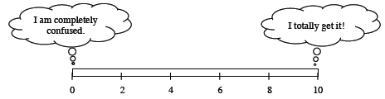
  + Color or shade in a portion of the bar that represents your level of understanding and comfort with completing that problem on your own.
* If any of your bars are less than a 5, choose *one* of those problems and complete one of the following tasks:
  + Write two questions that you would like to ask about that problem.
  + Brainstorm two things that you DO know about that type of problem.
* If all of your bars are a 5 or above, choose *one* of those problems and do one of these tasks:
  + Write two questions you might ask or hints you might give to a student who was stuck on the problem.
  + Make a new problem that is similar and more challenging than that problem and solve it.