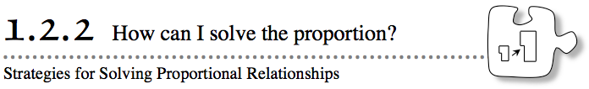
Proportional relationships can be identified in both tables and graphs. In the last lesson, you also used both of these representations to make predictions about proportional situations. Today you will continue to develop strategies for solving proportional situations using an equation.
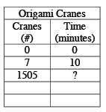
- 1-52. Kenny can make seven origami (folded-paper) cranes in ten minutes. He read a story about a girl who made 1505 cranes, so he was curious how long it would take him to make that many without stopping.
  - Complete Kenny’s table below, and then explain how you did so. How many minutes would it take Kenny to fold 1505 cranes? How many hours?
  - Instead of solving this problem using a table or a graph, Kenny represented seven cranes in ten minutes as the ratio . Then he wrote an equivalent ratio as follows:
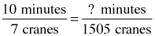
Use two different strategies to find the missing value in the equivalent ratio.
1-53. MULTIPLE STRATEGIES
Kenny’s class found several ways to solve $\frac{10}{7}=\frac{x}{1505}$. Three of the strategies that they used are presented below. Some of these strategies might be the same as what your class did in problem 1-52. However, others may be new. Work to understand each strategy so that you could use it to solve a new problem.
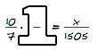
  - Giant One Method:
Multiplying a ratio by 1 does not change the value of the ratio. You can write 1 in many forms, such as $\frac{3}{3}$ and $\frac{14}{14}$. In this course, this kind of fraction is called a “Giant One.” Find a value to use as a numerator and denominator in a Giant One, and then find the value of x in the equation below.
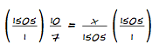
Undoing Division Method:
In this ratio, x is divided by 1505. You can undo the division by multiplying each side of the proportion by 1505 like this:
Work with your team to explain how this strategy works. Are the two ratios still equal? Why are both sides multiplied by 1505? Simplify each side of the equation and find x.
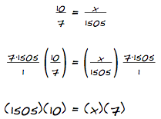
Fraction Buster Method:
If multiplying both sides by 1505 gets rid of the denominator of the x, then you can use the same strategy to get rid of the 7 in the other denominator. Discuss this method with your team and decide if undoing both denominators is a reasonable strategy. How does using this method help you solve the equation? What else do you need to do to find x?
1-54. Use each of the strategies from problem 1-53 to solve the problems below.
  - When he was little, Miguel could not sleep without his Captain Terrific action figure. It looked so life-like because it was a perfect scale model. The actor who plays Captain Terrific on television is 216 cm tall. Miguel’s doll is 10 cm tall. If the doll’s neck is 0.93 cm long, how long is the actor’s neck? Use the Undoing Division Method to solve this proportion: $\frac{216}{10}=\frac{x}{0.93}$.
  - The Northwood School Math Club is having a tamale sale. The school has 1600 students, but the club members are not sure how many tamales to make. One day during lunch, the club asked random students if they would buy a tamale. They found that 15 out of 80 students surveyed said they would definitely buy a tamale. How many tamales should the Math Club expect to sell? Use the Fraction Busters Method to solve the proportion: $\frac{15}{80}=\frac{x}{1600}$.
  - On the school copy machine, Mr. Douglas reduced a triangle so that it would fit better in student portfolios. The shortest side of the original triangle was 22 cm; other measurements are shown in the diagram. How long was the longest side of the original triangle? Solve the proportion $\frac{22}{8}=\frac{x}{12}$ using the Giant One Method.
1-55. Elsie is starting a recycling club at her school and hopes to use the money earned from recycling cans to buy recycling bins for the school.
Elsie first needs to figure out how much the cans that can be collected at her school weigh, so she starts by weighing the cans in her recycling bin at home. She finds that 50 cans weigh 0.8 kg. The next day, Elsie counts cans at school and finds that her fellow students throw away 1240 cans each day.
Solve the proportion below using a method of your choice to find how much all of the school’s cans weigh.

1-56. ANOTHER STRATEGY
Cross-Multiplication Method:
Juana’s method is shown at right.
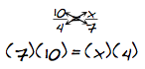
Explain to Juana why her method is really just a shortcut based on the Fraction Busters Method.

