Name:
Date:
Lesson 1.2.2 Homework
- 1-57. Solve each of the following proportions.

- If Joan read 75 pages in 4 hours how long will it take her to read 250 pages?

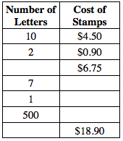
- 1-58. Mr. Wright was making a table to figure out how much it costs to send a certain number of regular letters through the mail. Use proportional reasoning to complete his table at right.

- 1-59. Kelly asked some of her classmates how many hours of sleep they get on school nights. Here are the results:
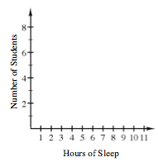
- 6, 8, 7$\frac{1}{2}$, 9, 8, 8, 8, 9, 9, 10, 6, 8$\frac{1}{2}$, 9, 7, 8
Create a histogram for the data using the graph to the right.

- 1-60. Define a variable and then write and solve an equation for the problem below. Remember that you can use the 5-D Process (described in the Lesson 1.1.3 Math Notes box) to help you get started. State your solution in a sentence.
Todd is 10 years older than Jamal. The sum of their ages is 64. How old are Todd and Jamal?

- 1-61. Simplify the following expressions.

- $-\frac{1}{3}±-\frac{3}{8}$
- $2.6-(-1.5)$
- $\left(-4\frac{1}{5}\right)\left(-\frac{1}{3}\right)$
- $\left(\frac{2}{3}\right)÷\left(-\frac{1}{2}\right)$
- $-1\frac{3}{4}+5\frac{1}{3}$
- $\left(-2.8\right)÷(-1.25)$

