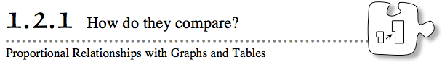

- You may recall studying about proportional relationships in a previous course. Today you will investigate proportional relationships in graphs and tables.
- 1-41. Make a table and a graph to represent each of the situations below.
  - Parvin often cleans the dishes for her mother. She can clean 17 plates in 10 minutes. How many plates can she clean in different amounts of time?
  - Yasmin’s puppy, Maggie, weighed 14 ounces at birth. She doubled her birth weight in 10 days. Assuming her growth is constant, how much will she weigh at various times in the first year?
  - Angel saw an Internet pop-up advertisement for an investment that doubles your money every year. If Angel invests the $20 her grandmother gave her for her birthday, how much money will she have in various years?
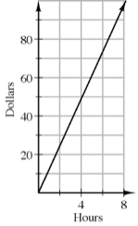
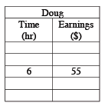
  - Which of the situations in parts (a) through (c) describe a proportional relationship? How do you know if a relationship is proportional by looking at the table? What about by looking at the graph?
- 1-42. Doug regularly mows his neighbor’s lawn. Last month, Doug’s neighbor paid him $55 for 6 hours of mowing.
  - Is this situation most likely a proportional relationship? How do you know?
  - Make a table that shows how much Doug earns for various numbers of hours of mowing.
  - Johnny brags that he is getting paid more than Doug to mow lawns. Johnny gets paid according to the graph below right. Who is getting paid more? How do you know?
  - At what unit rate do Johnny and Doug each get paid? How do you know? Remember that a unit rate compares the change in one quantity to a one-unit change in another quantity, so in this case you would compare dollars to one hour.
  - If it is not already there, how could you show the unit rate in Doug’s table? How could you show the unit rate on Johnny’s graph?
1-43. Ferroza’s pet ferret eats so much that Ferroza has to buy ferret food in bulk. Five pounds cost $17.50, and 30 pounds cost $105.00.
  - Make a graph of the cost of ferret food for various sizes of bags.
  - Calculate the value of y at the point (1, y) on Ferroza’s graph. Why would Ferroza want to know what the value of y is?

1-44. Toby wrote the equation t = $\frac{7}{10}$m to represent the relationship between the number of tubes of toothpaste (t) he uses in any number of months (m).
  - How much toothpaste does Toby use in 5 years? Show how you found this.
  - Toby’s sister kept track of her toothpaste use in the following table.
Who uses toothpaste faster, Toby or his sister?
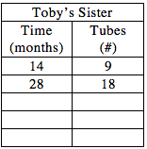
  - If you have not already done so, find the unit rate (in tubes/month) for both Toby and his sister. Do the unit rates confirm your answer to part (b)?
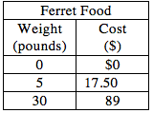
1-45. The larger bag of ferret food is on sale at the SuperPetMart for $89. Ferroza made the following table. Explain to Ferroza why the cost of food at SuperPetMart is not a proportional relationship.

