Name:
Date:
Lesson 1.2.1 Homework
- 1-47. Decide whether each of the following situations represents a proportional relationship. Explain why or why not.
- Karim is ordering video games. Each game costs $39.99, and there is a $4.85 shipping charge per order. How much will it cost him to order any number of video games?

- A given rectangle has an area of 20 square feet. What is the length for various widths?

- Oleg ran 8.8 miles in 1 hour 20 minutes. Assuming he continues at a constant rate, how long will it take him to run any number of miles?

1-48. Jerome is keeping track of how many books he and his friends have read during the first 100 days of school. To help Jerome present the data to his teacher, make a box plot of how many books each person has read. The numbers of books are 12, 17, 24, 18, 31, 17, 21, 20, 14, 9, and 25.

1-49. Simplify the following expressions.

- $-0.75-0.4$
- $\frac{7}{8}-\frac{2}{3}$
- $0.65-0.89$
- $\frac{11}{12}+\frac{4}{9}$
- $\frac{9}{10}∙2\frac{1}{3}$
- $12÷\frac{7}{8}$
- $1\frac{2}{3}+\left(-\frac{2}{5}\right)$
- $\frac{4}{7}-\left(-\frac{3}{8}\right)$
- $-4.05+3.18$

1-50. Look at each graph below and write a story or description about what each graph shows.
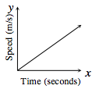
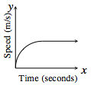
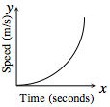
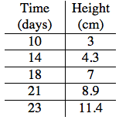
1-51. Riley was monitoring the growth of his favorite tomato plant and collected the data shown in the table at right.
- Graph Riley’s data.
- What can you tell Riley about his plant based on the data?
