Name:
Date:
Lesson 1.1.4 (Part 2) Homework
1-34. Compute without using a calculator.

- −15 + 7
- 8 − (−21)
- 6 (−8)
- −9 + (−13)
- −50 − 30
- 3 − (−9)
- −75 − (−75)
- (−3) + 6
- 9 + (−14)
- 28 − (−2)
- −3 + (−2) + 5
- 3 + 2 + 5

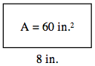
1-35. The area of each rectangle below is shown in the middle of the rectangle. For each figure, find the missing length or width.
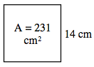
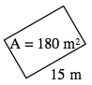

1-37. Latisha earned an 85% today. Her previous scores were 72%, 89%, and 90%. Calculate her new average (mean).

