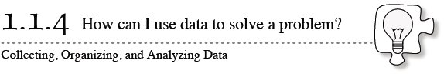
- Computing batting averages, performing scientific experiments, and polling people during elections are just a few examples of how data can provide useful information when it is collected and analyzed. In this lesson, you will be collecting and organizing data to determine the potential danger of riding a roller coaster.
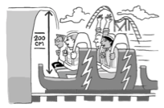
1-24. NEWTON’S REVENGE
- Have you heard about Newton’s Revenge, the new roller coaster? It is so big, fast, and scary that rumors about it are already spreading. Some people are worried about the tunnel that thrills riders with its low ceiling.
- The closest the ceiling of the tunnel ever comes to the seat of the roller-coaster car is 200 cm. Although no accidents have been reported yet, it is said that very tall riders have stopped riding the roller coaster.
- Your Task: Consider how you could determine whether the tunnel is actually safe for any rider, no matter how tall. Discuss the questions below with your team. Be ready to share your responses with the rest of the class.
- What is this problem about? What is it asking you to do?

- What information can help you answer this question?

- How can you get the information you need?

- 1-25. One way to determine if the roller coaster is safe is to collect and analyze data.
  - Collect data from each member of your team.
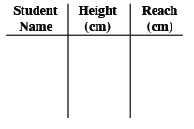
Each member of the team needs to be measured twice. First, have one team member stand and have another team member measure his or her height. Second, have the same student sit in a chair or desk, raise his or her arms so that they are stretched as far as possible above his or her head, and measure the distance from the seat of the chair to his or her fingertips (called “the reach”). All measurements should be in centimeters.
Each person should record the team’s data in a table like the one above.
  - Send one person up to record your team’s data on the class table. Then add the rest of the class data to your own table.
  - Each person should put his or her initials on a sticky dot, then graph his or her own height vs. reach point on the class graph.

