Name:
Date:
Lesson 1.1.4 (Part 1) Homework
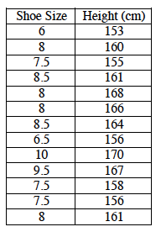
1-30. Kerin discovered that a human’s height is related to his or her reach. Kerin is curious if the same thing is true for foot size.
  - It was not practical for Kerin to measure her classmates’ feet, so Kerin collected the following shoe-size data from some of her classmates. Make a graph with appropriately scaled axes.

  - Is there a relationship between shoe size and height?

1-32. Latisha is determined to do well in school this year. Her goal is to maintain at least an 85% average (mean) in all of her courses.
- Latisha started her history class with two scores on tests, 72% and 89%. Confirm that the mean of these two scores is 80.5%. Show your work.

- Latisha’s third score was 90%. Use her scores from part (a) to figure out her mean now. Be sure to show your work.

1-33. Use the pattern you discovered earlier to complete each of them. The pattern is shown at right. Some of these may be challenging!
