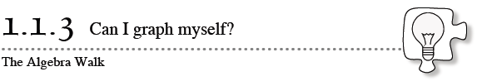

Today you will use a xy-coordinate system to refer to the locations of specific points in the form (x, y). By the end of this lesson, be sure you and your teammates know the answers to the following target questions.
How can you plot a point using its (x, y) coordinates?
How can you name a point on the graph?
How can you describe a pattern formed by points?
- 1-17. ALGEBRA WALK
- The Algebra Walk is an exercise in “human graphing” where people represent points on a graph. Your teacher will give the class instructions for how to form human graphs. Then you will work in study teams to complete the problems below.
- For each of the following rules, copy and complete the table. Then neatly graph each point. Use the resource page provided by your teacher.
- The x-values in the table are sometimes referred to as input values, since they are the values used with the rule for x. The y-values are the output values, since they are the result of what happens to the input (x) value.
- 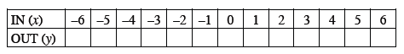
  - y = 2x + 1
  - y = –2x
  - y = x + 4
  - y = –x + 4
  - y = x²

- 1-18. Describe what you did and what you observed in today’s classwork.
  - Compare the graphs in 1-17. How are they similar? How are they different?.

  - Using words, express each symbolic rule in parts (a) through (e).

  - Did you notice any patterns? Why was it easy to spot someone who was out of place?

