Often, mathematics is described as “the study of patterns.” Today you will preview future work with patterns by studying two tile patterns and using them to make predictions. As you work on these patterns, consider the following questions:
How do I see the pattern?
How is it changing?
Is there another way to find a solution?
- 1-8. When you are working with your team to answer questions and solve the problems in this course, it is important to work effectively with other people. Effective math conversations are a valuable part of the learning process throughout this course. Choose a member of your team to read the “Collaborative Learning Expectations” below out loud.
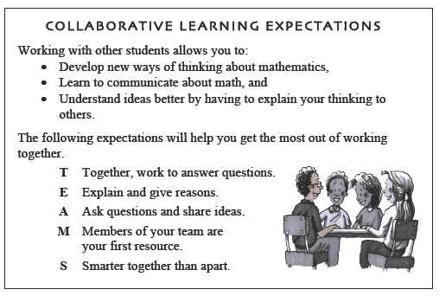

- 1-9. GROWING, GROWING, GROWING, PART ONE
Copy the tile pattern shown below onto graph paper.
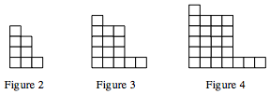
- Draw the 1st, 5th, and 6th figures on your paper.
- How is the pattern changing?
- What would the 100th figure look like? How many tiles would it have? How can you justify your prediction?
1-10. GROWING, GROWING, GROWING, PART TWO
- Examine this new tile pattern. Copy it onto your paper.
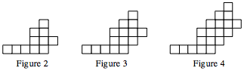

  - Draw the 1st, 5th, and 6th figures on your paper.
  - Michael knows that one of the figures in this tile pattern has 79 tiles. What is its figure number? There are many ways to figure this out − be sure to listen to each person's ideas about how to find a solution. Be prepared to explain how you answered this question.
1-11. For the pattern that your teacher assigns to you, from either problem 1-9 or problem 1-10, prepare a team presentation or poster with your description of the pattern and your prediction. Every team paper or poster should include:
  - Clear drawings of figures from your pattern.
  - An explanation of the pattern you found.
  - Your prediction. (Make sure your reasoning is clear!)

