Name:
Date:
Lesson 1.1.2 Homework
1-12. Examine the tile pattern at right.
  - Sketch Figures 4 and 5.
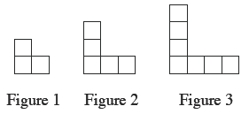

  - How does the pattern grow? Explain how you know.

  - How many tiles will there be in Figure 100? Explain how you know.

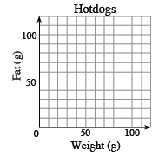
1-13. Add an appropriate scale to the graph and then place and label a point on the graph for each of the products listed below.
- Dog-Eat-Dog has a supreme hotdog that weighs 80 grams and has 40 grams of fat.
- Hot Doggies has a diet hotdog that weighs 50 grams and has only 9 grams of fat.
- Dog-alicious has a cheap hotdog that weighs 40 grams and has 30 grams of fat.
1-14. Copy and complete each sequence below. Using words, not numbers, describe how the patterns work. (For example, write, “Double the previous number.”)
- 1, 3, 6, 10, ____, ____
- 1, $\frac{1}{2}$ ,$\frac{1}{4}$ ,$\frac{1}{8}$ , ____, ____
- 1, 3, 9, 27, ____, ____
- 8, 7, 5, 2, ____, ____
- 49, 47, 52, 50, 55, ____, ____

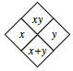
1-15. Recall the Diamond Problem pattern that you found in problem 1-4, which is represented in the diamond below. Copy and complete the Diamond Problems below using the same pattern.
- 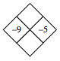
- 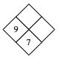
- 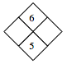
- 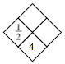
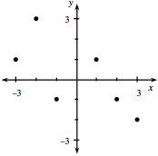
1-16. Use the graph at right to answer the following questions about quadrants and coordinates of points.
- What are the coordinates of the two points in Quadrant II?

- What are the coordinates of the two points in Quadrant IV?

